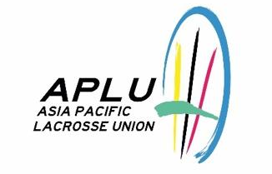
Event Sanctioning Request Form
Please complete all sections and submit with required attachments.
Date of Submission: _______________________________
Section 1: Applicant Information
Organization Name
Country / Region
Representative Name
Title / Position
Phone Number
Email Address
Section 2: Event Overview
Event Name
Organizer / LOC
Co-organizer(s)
Event Purpose & Objectives
Event Format / Type
Event Date(s)
Host Country / City
Venue
Expected Spectators
Expected Participants
Participation Fee to Teams

Section 3: Reason for Sanctioning Request
Reason for Requesting APLU Sanctioning
Support Requested from APLU
Other Endorsing Bodies
Section 4: Required Attachments
Please confirm the following documents are included with this application:
☐ | Application Form (this document — tournament outline and objectives)
☐ | Budget (itemized income and expenditure)
☐ | Officer and Organizing Committee Member List with contact information
☐ | Proposed Event Schedule / Program
☐ | Supplemental materials (pamphlets, posters, etc.) — if available
Section 5: Declaration
The applicant hereby confirms the following:
☐ | The event is organized on a non-profit basis. Administrative costs and labor fees may be included in the budget.
☐ | The event will take place within the APLU region.
☐ | If the organizing body is not affiliated with APLU, separate endorsement from the respective NGB of the host country has been (or will be) obtained. (Not required if no NGB exists in the host country.)
☐ | An end-of-event report (including results, participant/visitor numbers, and financial statement) will be submitted to APLU within 90 days of the event.
☐ | The applicant has read and agrees to comply with the APLU Event Sanctioning Policy.
Signature of Authorized Representative
Name |  | Title
Signature |  | Date
— FOR APLU USE ONLY —
Date Received |  | Reviewed by
Board Decision |  | Decision Date
Notes
Please submit this form and all attachments to: chris.jinno@asiapacificlacrosse.org

